**Project B Case description**

*Case***:** Airline

2021-2022 OP 3&4

 --------------------------------------------------------------------------------------------------------------------------

Now that Rotterdam South is becoming more and more important for the city, the wish has arisen that it should also be possible to fly from Rotterdam South. In addition, the city also sees that it would be good to divide the air traffic a bit more and not only use the current Rotterdam The Hague Airport. As an entrepreneur Jake Darcy is going to get involved in this business.

Jake is going to start an airport where sustainability is paramount. He is going to start small, initially only flying within Europe. He will be using his own planes and has set up his own airline: Rotterdam Airlines. Rotterdam Airlines has initially 3 aircrafts at its disposal. A Boeing 737, Airbus 330 and a Boeing 787.

The airport will be located in Rotterdam, namely: "Driemanssteeweg 107, 3011 WN in Rotterdam". User-friendliness will be at the top of the list of priorities. This is reflected in everything that has to do with the airport and booking a flight. Jake also devised a way to determine the price per seat.

Anyone who has ever been on an airplane knows that the seat you sit in can make a lot of difference in terms of comfort. Think, for example, of sitting on the first or last row or sitting next to the window. The plans of the airplanes are shown schematically below:

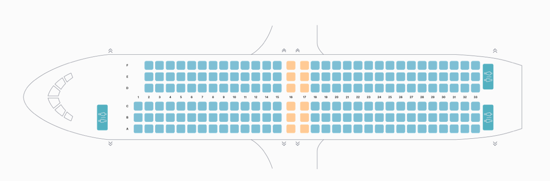

Boeing 737

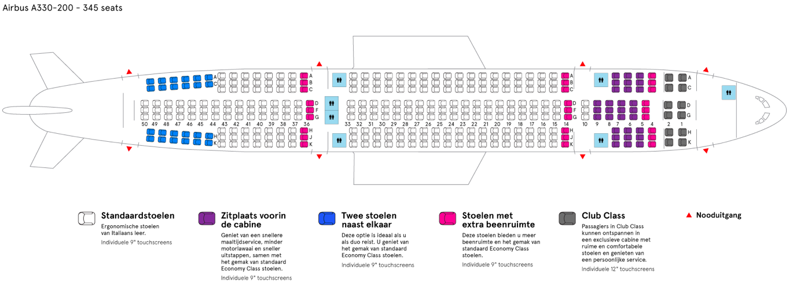

Airbus 330

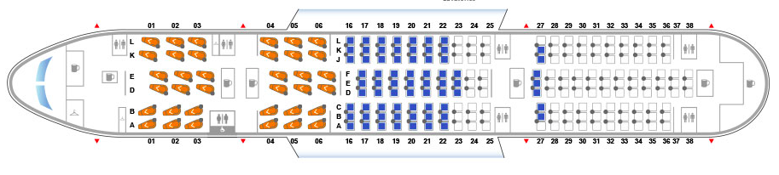

Boeing 787

Jake is in need of a reservation console application You and your team are hired to make this application.

Possible features:

* Reservation of available chairs.
* Information about the airport
* Price depends on the chair you book
* overview of possible destinations and available flights
* Sort the flights on time, price etc
* Catering possibilities on the airport/flight
* Get a reservation code when you book a flight
* Overview total costs of my reservation
* Overview available seats and price
* Contact details for the airport
* Choose a specific chair
* Etc.